import tensorflow as tf import tensorflow_hub as hub

import matplotlib.pyplot as plt import numpy as np

import pandas as pd import seaborn as sns

from tensorflow.keras.utils import get_file

from sklearn.metrics import roc_curve, auc, confusion_matrix from imblearn.metrics import sensitivity_score, specificity_score

import os import glob import zipfile import random

# to get consistent results after multiple runs tf.random.set_seed(7)

np.random.seed(7) random.seed(7)

# 0 for benign, 1 for malignant class_names = ["benign", "malignant"]

**Preparing the Dataset**

def download_and_extract_dataset():

# dataset from https://github.com/udacity/dermatologist-ai # 5.3GB

train_url = "https://s3-us-west-1.amazonaws.com/udacity- dlnfd/datasets/skin-cancer/train.zip"

# 824.5MB

valid_url = "https://s3-us-west-1.amazonaws.com/udacity- dlnfd/datasets/skin-cancer/valid.zip"

# 5.1GB

test_url = "https://s3-us-west-1.amazonaws.com/udacity- dlnfd/datasets/skin-cancer/test.zip"

for i, download_link in enumerate([valid_url, train_url, test_url]): temp_file = f"temp{i}.zip"

data_dir = get_file(origin=download_link, fname=os.path.join(os.getcwd(), temp_file))

print("Extracting", download_link)

with zipfile.ZipFile(data_dir, "r") as z: z.extractall("data")

# remove the temp file os.remove(temp_file)

# comment the below line if you already downloaded the dataset download_and_extract_dataset()

# preparing data

# generate CSV metadata file to read img paths and labels from it def generate_csv(folder, label2int):

folder_name = os.path.basename(folder) labels = list(label2int)

# generate CSV file

df = pd.DataFrame(columns=["filepath", "label"]) i = 0

for label in labels:

print("Reading", os.path.join(folder, label, "*"))

for filepath in glob.glob(os.path.join(folder, label, "*")): df.loc[i] = [filepath, label2int[label]]

i += 1

output_file = f"{folder_name}.csv" print("Saving", output_file) df.to_csv(output_file)

# generate CSV files for all data portions, labeling nevus and seborrheic keratosis

# as 0 (benign), and melanoma as 1 (malignant)

# you should replace "data" path to your extracted dataset path

# don't replace if you used download_and_extract_dataset() function generate_csv("data/train", {"nevus": 0, "seborrheic_keratosis": 0,

"melanoma": 1})

generate_csv("data/valid", {"nevus": 0, "seborrheic_keratosis": 0,

"melanoma": 1})

generate_csv("data/test", {"nevus": 0, "seborrheic_keratosis": 0,

"melanoma": 1})

# loading data train_metadata_filename = "train.csv" valid_metadata_filename = "valid.csv" # load CSV files as DataFrames

df_train = pd.read_csv(train_metadata_filename) df_valid = pd.read_csv(valid_metadata_filename) n_training_samples = len(df_train) n_validation_samples = len(df_valid)

print("Number of training samples:", n_training_samples)

print("Number of validation samples:", n_validation_samples)

train_ds = tf.data.Dataset.from_tensor_slices((df_train["filepath"], df_train["label"]))

valid_ds = tf.data.Dataset.from_tensor_slices((df_valid["filepath"], df_valid["label"]))

Number of training samples: 2000 Number of validation samples: 150

# Copy

Let's load the images:

# preprocess data def decode_img(img):

# convert the compressed string to a 3D uint8 tensor img = tf.image.decode_jpeg(img, channels=3)

# Use `convert_image_dtype` to convert to floats in the [0,1] range. img = tf.image.convert_image_dtype(img, tf.float32)

# resize the image to the desired size.

return tf.image.resize(img, [299, 299])

def process_path(filepath, label):

# load the raw data from the file as a string img = tf.io.read_file(filepath)

img = decode_img(img) return img, label

valid_ds = valid_ds.map(process_path) train_ds = train_ds.map(process_path) # test_ds = test_ds

for image, label in train_ds.take(1): print("Image shape:", image.shape) print("Label:", label.numpy())

Image shape: (299, 299, 3)

Label: 0

# training parameters batch_size = 64 optimizer = "rmsprop"

def prepare_for_training(ds, cache=True, batch_size=64, shuffle_buffer_size=1000):

if cache:

if isinstance(cache, str): ds = ds.cache(cache)

else:

ds = ds.cache() # shuffle the dataset

ds = ds.shuffle(buffer_size=shuffle_buffer_size) # Repeat forever

ds = ds.repeat()

# split to batches

ds = ds.batch(batch_size)

# `prefetch` lets the dataset fetch batches in the background while the model

# is training.

ds = ds.prefetch(buffer_size=tf.data.experimental.AUTOTUNE) return ds

valid_ds = prepare_for_training(valid_ds, batch_size=batch_size, cache="valid-cached-data")

train_ds = prepare_for_training(train_ds, batch_size=batch_size, cache="train-cached-data")

batch = next(iter(valid_ds))

def show_batch(batch): plt.figure(figsize=(12,12)) for n in range(25):

ax = plt.subplot(5,5,n+1) plt.imshow(batch[0][n])

plt.title(class_names[batch[1][n].numpy()].title()) plt.axis('off')

show_batch(batch)

Output:

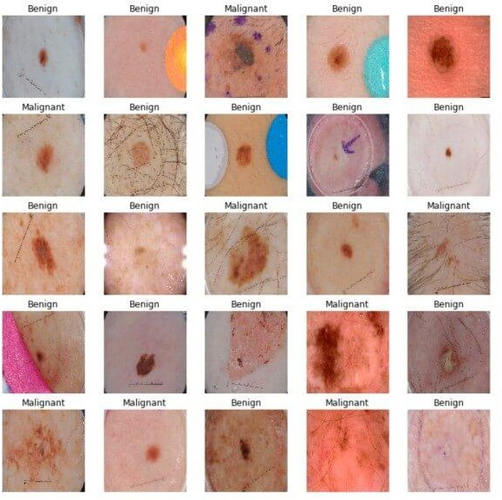

# building the model

# InceptionV3 model & pre-trained weights

module_url = "https://tfhub.dev/google/tf2- preview/inception_v3/feature_vector/4"

m = tf.keras.Sequential([

hub.KerasLayer(module_url, output_shape=[2048], trainable=False), tf.keras.layers.Dense(1, activation="sigmoid")

])

m.build([None, 299, 299, 3])

m.compile(loss="binary_crossentropy", optimizer=optimizer, metrics=["accuracy"])

m.summary()

|  |  |
| --- | --- |
| Model: "sequential" |  |
| Layer (type) Output Shape Param # |
| ================================================================= |
| keras_layer (KerasLayer) multiple 21802784 |
| dense (Dense) multiple 2049 |
| ================================================================= |
| Total params: 21,804,833 |
| Trainable params: 2,049 |
| Non-trainable params: 21,802,784 |
|  |

**Training the Model**

We now have our dataset and the model, let's get them together:

model_name = f"benign-vs-malignant_{batch_size}_{optimizer}"

tensorboard = tf.keras.callbacks.TensorBoard(log_dir=os.path.join("logs", model_name))

# saves model checkpoint whenever we reach better weights

modelcheckpoint = tf.keras.callbacks.ModelCheckpoint(model_name + "_{val_loss:.3f}.h5", save_best_only=True, verbose=1)

history = m.fit(train_ds, validation_data=valid_ds,

steps_per_epoch=n_training_samples // batch_size, validation_steps=n_validation_samples // batch_size,

verbose=1, epochs=100,

callbacks=[tensorboard, modelcheckpoint])

Here is a part of the output during training:

Train for 31 steps, validate for 2 steps Epoch 1/100

30/31 [============================>.] - ETA: 9s - loss: 0.4609 -

accuracy: 0.7760

Epoch 00001: val_loss improved from inf to 0.49703, saving model to benign-vs-malignant_64_rmsprop_0.497.h5

31/31 [==============================] - 282s 9s/step - loss: 0.4646 -

accuracy: 0.7722 - val_loss: 0.4970 - val_accuracy: 0.8125

<..SNIPED..>

Epoch 27/100

30/31 [============================>.] - ETA: 0s - loss: 0.2982 -

accuracy: 0.8708

Epoch 00027: val_loss improved from 0.40253 to 0.38991, saving model to benign-vs-malignant_64_rmsprop_0.390.h5

31/31 [==============================] - 21s 691ms/step - loss: 0.3025

- accuracy: 0.8684 - val_loss: 0.3899 - val_accuracy: 0.8359

<..SNIPED..>

Epoch 41/100

30/31 [============================>.] - ETA: 0s - loss: 0.2800 -

accuracy: 0.8802

Epoch 00041: val_loss did not improve from 0.38991

31/31 [==============================] - 21s 690ms/step - loss: 0.2829

- accuracy: 0.8790 - val_loss: 0.3948 - val_accuracy: 0.8281 Epoch 42/100

30/31 [============================>.] - ETA: 0s - loss: 0.2680 -

accuracy: 0.8859

Epoch 00042: val_loss did not improve from 0.38991

31/31 [==============================] - 21s 693ms/step - loss: 0.2722

- accuracy: 0.8831 - val_loss: 0.4572 - val_accuracy: 0.8047

## Model Evaluation

First, let's load our test set, just like previously:

# evaluation

# load testing set test_metadata_filename = "test.csv"

df_test = pd.read_csv(test_metadata_filename) n_testing_samples = len(df_test)

print("Number of testing samples:", n_testing_samples)

test_ds = tf.data.Dataset.from_tensor_slices((df_test["filepath"], df_test["label"]))

def prepare_for_testing(ds, cache=True, shuffle_buffer_size=1000):

if cache:

if isinstance(cache, str): ds = ds.cache(cache)

else:

ds = ds.cache()

ds = ds.shuffle(buffer_size=shuffle_buffer_size) return ds

test_ds = test_ds.map(process_path)

test_ds = prepare_for_testing(test_ds, cache="test-cached-data")

The above code loads our test data and prepares it for testing:

Number of testing samples: 600

images of the shape

600

(299, 299, 3)

set from tf.data into a NumPy array:

can fit our memory, let's convert our test

# convert testing set to numpy array to fit in memory (don't do that when testing

# set is too large)

y_test = np.zeros((n_testing_samples,))

X_test = np.zeros((n_testing_samples, 299, 299, 3))

for i, (img, label) in enumerate(test_ds.take(n_testing_samples)): # print(img.shape, label.shape)

X_test[i] = img y_test[i] = label.numpy()

print("y_test.shape:", y_test.shape) # load the weights with the least loss

m.load_weights("benign-vs-malignant_64_rmsprop_0.390.h5") print("Evaluating the model...")

loss, accuracy = m.evaluate(X_test, y_test, verbose=0) print("Loss:", loss, " Accuracy:", accuracy)

# Copy

Output:

Evaluating the model...

Loss: 0.4476394319534302 Accuracy: 0.8

The below function does that:

def get_predictions(threshold=None): """

Returns predictions for binary classification given `threshold`

For instance, if threshold is 0.3, then it'll output 1 (malignant) for that sample if

the probability of 1 is 30% or more (instead of 50%) """

y_pred = m.predict(X_test) if not threshold:

threshold = 0.5

result = np.zeros((n_testing_samples,)) for i in range(n_testing_samples):

# test melanoma probability if y_pred[i][0] >= threshold:

result[i] = 1

# else, it's 0 (benign) return result

threshold = 0.23

# get predictions with 23% threshold

# which means if the model is 23% sure or more that is malignant, # it's assigned as malignant, otherwise it's benign

y_pred = get_predictions(threshold)

Now let's draw our confusion matrix and interpret it:

def plot_confusion_matrix(y_test, y_pred): cmn = confusion_matrix(y_test, y_pred)

# Normalise

cmn = cmn.astype('float') / cmn.sum(axis=1)[:, np.newaxis]

# print it print(cmn)

fig, ax = plt.subplots(figsize=(10,10)) sns.heatmap(cmn, annot=True, fmt='.2f',

xticklabels=[f"pred_{c}" for c in class_names], yticklabels=[f"true_{c}" for c in class_names], cmap="Blues"

)

plt.ylabel('Actual') plt.xlabel('Predicted')

# plot the resulting confusion matrix plt.show()

plot_confusion_matrix(y_test, y_pred)

Output:

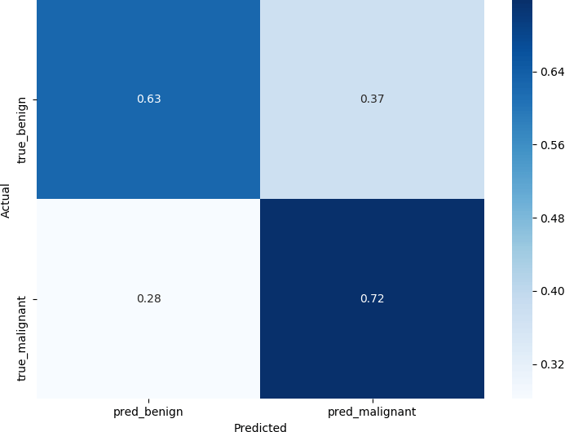

def plot_roc_auc(y_true, y_pred): """

This function plots the ROC curves and provides the scores. """

# prepare for figure plt.figure()

fpr, tpr, _ = roc_curve(y_true, y_pred) # obtain ROC AUC

roc_auc = auc(fpr, tpr) # print score

print(f"ROC AUC: {roc_auc:.3f}") # plot ROC curve

plt.plot(fpr, tpr, color="blue", lw=2,

label='ROC curve (area = {f:.2f})'.format(d=1,

f=roc_auc))

plt.xlim([0.0, 1.0])

plt.ylim([0.0, 1.05]) plt.xlabel('False Positive Rate') plt.ylabel('True Positive Rate') plt.title('ROC curves') plt.legend(loc="lower right") plt.show()

plot_roc_auc(y_test, y_pred)

# Copy

Output:

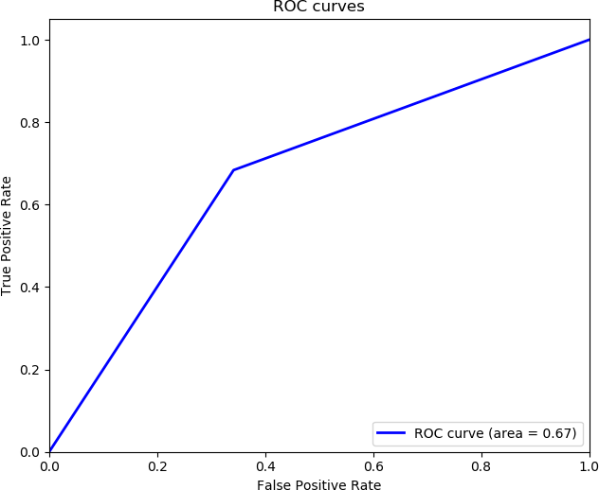

ROC AUC: 0.671